Side Plank Holds: Program 1 SuperFitMum

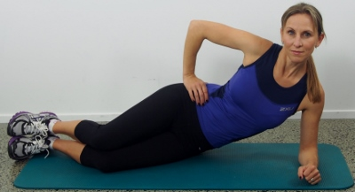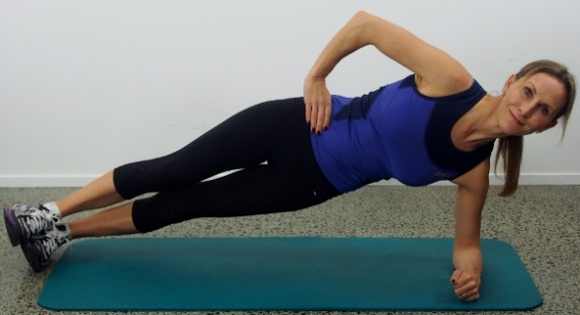

All the exercises included in the SuperFitMum Programs are 100% totally Tummy safe. That means if you still have a diastasis after 12-16 weeks following the birth2fitmum program the exercises will not make it worse they will continue to heal your diastasis

Start with your elbow directly under your shoulder, keep your knees bent to start with you can take your legs out and have them straight as you advance. Activate your TVA’s before you lift up and feel your oblique muscles engage as you lift your hips up high.
Hold the position for 5 breaths and repeat 5 times before repeating on the opposite side.

Avoid falling back; try to keep your top hip slightly forward as opposed to completely vertical.

Benefits:
This exercise helps to increase the strength in your oblique muscles, the muscles at the sides of your torso. Shape your sexy mid-line

