SuperFitMum-Stretch Guide
Quadriceps  Standing | 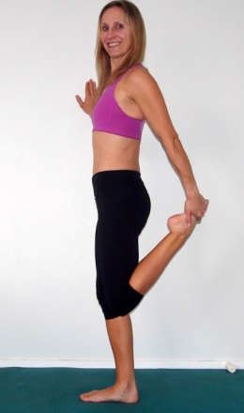 | Try not to Arch your lower back.  Stand up tall  Fell the stretch in the front of your thigh. | If you have tight and dominant quads you can do this stretch between your exercises
Quadricep & Hip Flexors  Lying | 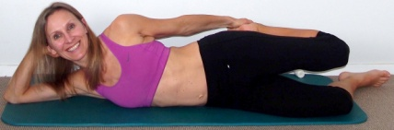 | Hold your ankle, without arching your lower back.  Keep hold, tight and place your other foot on top and press down | This is a hard stretch to get right but once you can feel the stretch in the correct muscle you will feel the benefits
Hip Flexors/Psoas muscle | 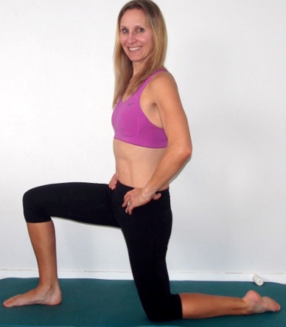 | Avoid Arching lower back
Hamstring Lying | 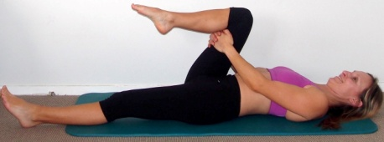  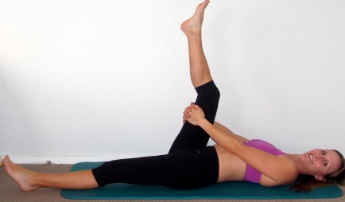 | Pull your leg in towards you keeping your thigh vertical.  Try to keep your shoulders and neck relaxed as you extend your leg up. | If you can straighten your leg and pull further towards you without feeling a stretch you do not need to stretch your hamstring muscles
 | 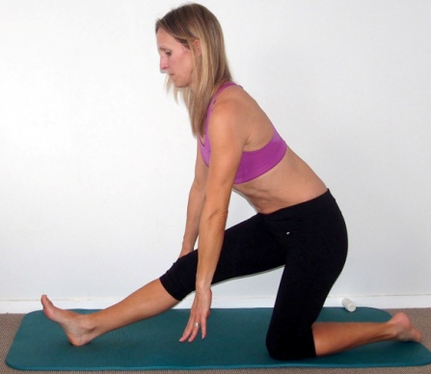
Piriformis  (Deep Glute)  Seated | 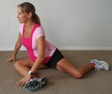 | Keep your chest up  Lean forwards towards your bent knee  Both knee angles are 90 degrees | If you can’t feel the stretch you don’t need to do it.  This is a good stretch from 25-35 weeks pregnant
Erectore Spinea  (Lower back), latisimis dorsi (Middle back) & chest if you widen your arms |  | Knees out wider the further into your pregnancy. | Use this stretch frequently to relax
Quadratus Lumborem (Q.L)  Side of torso  Using your wall, side and back view. Cross your legs over to also feel a stretch in your T.F.L tensor fasciae latae muscle at the top of your leg/hip  Or  On the floor from a kneeling position | 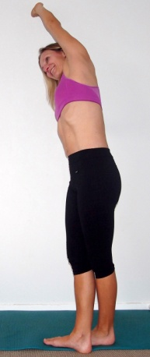  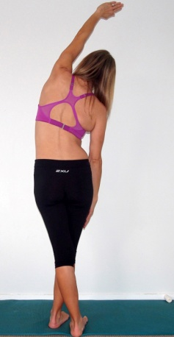  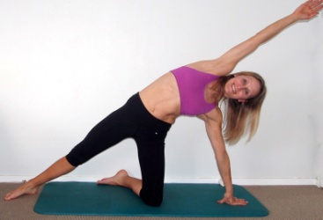 | Aim to keep your arm, back and shoulder against the wall
Pectorals; Chest Stretches | 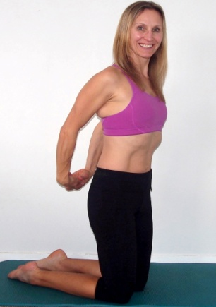 | Try to do this stretch daily

If you feel any pain or discomfort whilst exercising, stop. If pain continues consult you G.P. The information included in this program has been written by Lorraine Scapens: She is not able to provide you with medical. You cannot hold Lorraine liable in any way for any injuries that may occur whilst training. This Program has been written by Lorraine Scapens it is not yours to sell or copy November 2013.

