SuperFitMum- Program 1
Do this program for 4 weeks
Time: Should take 35-40minutes once you know what you are doing from start to finish. If you are short of time just do 2 sets of each exercise, or chooses one of the 20minute workout with me sessions
Your Start Date______________

Warm Up 1 or 5-10mins of your choice of exercise:  Video Exercises:-  One Leg Slide Outs x 10 each leg  One Arm Alt. Wall Press x 10  Side Steps x20  Measurements:  Diastasis Recti- if any:  Width  Vertical  Depth  Body Measurements:  Bust:  Waist:  Hips:  Abdominals (widest part-relaxed):  Abdominals with TVA activate:  Top of Leg:  Top of Arm: | Stretches To do First:  Quads & Hip Flexors-  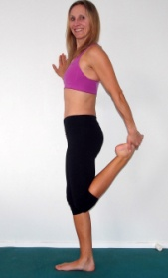  Chest- Do standing  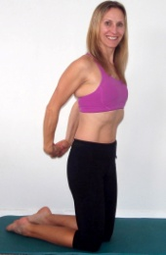 | Notes:  Circuit explanation  In the SuperFitMum program you are going to challenge yourself. In the program I group exercises together for you to do in a circuit.  2-3 exercises will be grouped and what you do is perform 1 set of each exercise then repeat the circuit.  I want you to try to do the circuit with minimal rest; you can rest once you have completed the circuit and before you move on to the next one!
Exercise | Tips | Reps & Sets
Side Plank Holds  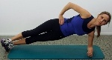 | Lift your hips up and slightly rotate forward, avoid leaning back | 3 x 30 seconds on each side (in total)
Hip Bridge One leg Butt Blaster:  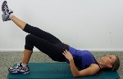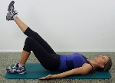 | Keep your hip bones level, focus on using your glutes and activating your abdominal muscles | 3 x 10 each leg
 |  | Circuit Side Plank Holds and Hip Bridge
Ballerina:  Holding dumbbells in each hand or Kettlebells, can also use cans/water bottles or do without  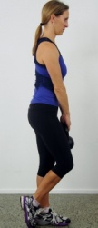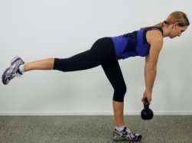 | Maintain great technique; concentrate on working your glutes! | 3 x 10 reps  Use 2-6kg weights
Wall Sit with Sideways Drop  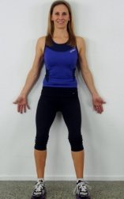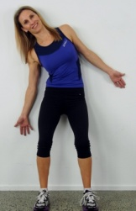 | Avoid pressing your lumbar spine in towards the wall,  Keep your shoulders relaxed and your hips still.  Try to focus on your TVA and Oblique muscles. | 3 x 8-10
Band: One Arm Chest Press  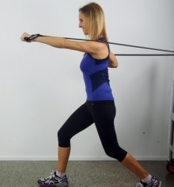 | Good posture, strong abdominal activation to stabilize your torso and pelvis, keep your shoulders relaxed as you press.  Opposite arm to leg | 3 x 10-12
 |  | Circuit Ballerina, side drop and chest with minimal if any rest
Band: Crabs  Side steps-no band side leg lift with support  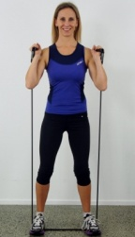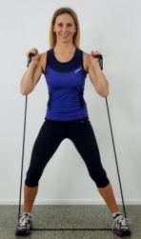 | Step out as wide as you can, turn your toes out slightly and work your butt! | 3 x 20 (in total)
Reverse Alternating Lunges:  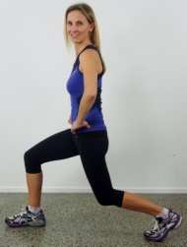 | Keep your chest up, press into your heel and focus on using your glutes and quads | 3 x 20 (in total not each leg)
Band: Double Back Pull  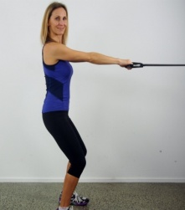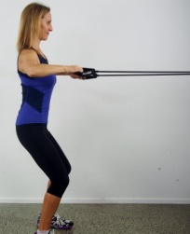 | Make sure you find a solid object to wrap your band around. A tree will do!  Alternative Dumbbell rows.  Shoulders down, squeezing your shoulders back. | 3 x 10-12
 |  | Circuit Side Steps, Lunges and Pulls again try to have minimal rest you can have a rest and a drink of water before starting the next circuit
Squat & Swing: No Kettlebell or dumbbell use a football  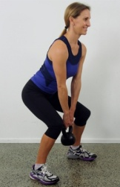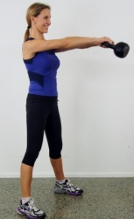 | Maintain good technique, swing using your glutes, quads adductors and abdominal muscles! BIG exercise! | 3 x 10-15 use 4-20kg KB  Start off light and build
Couch Push Off Press ups  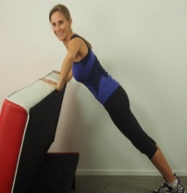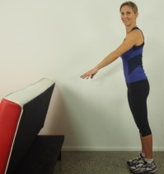 | You can also use a bar/fence.  When you push off connect with your upper body muscles and maintain connection with your core muscles | 3 x 10-12
Step or Box: Run Ups  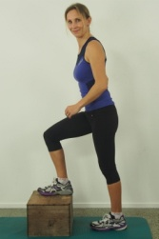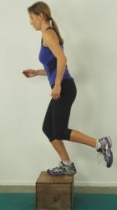 | Make sure your step box etc is strong enough to hold more than your body weight. | 3 x 10 each leg see if you can build to 15 reps on each leg during SFM1
 |  | Circuit Swing, Push off and Run ups
TVA Leg Slides  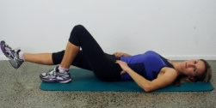 | Now is the time to re-connect and relax. Focus on your TVA muscles  Do at the same speed I do in the video, slow down and connect correctly | 3 x 12 reps
Stretches do now after your program or later in the evening when you may have more time to relax.
Quads  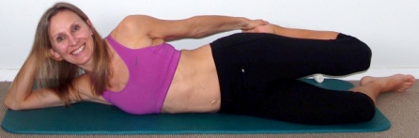 | Hamstrings  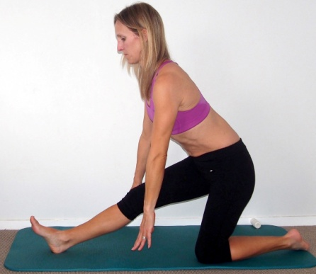 | Lower Back and Chest

If you feel any pain or discomfort whilst exercising, stop. If pain continues consult you G.P. The information included in this program has been written by Lorraine Scapens: She is not able to provide you with medical. You cannot hold Lorraine liable in any way for any injuries that may occur whilst training. This Program has been written by Lorraine Scapens it is not yours to sell or copy November 2013.

